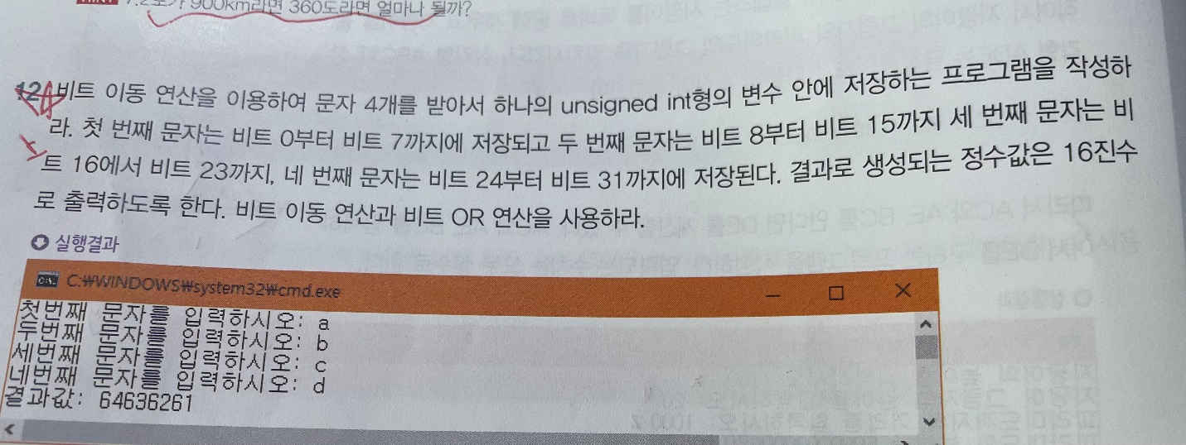

#include<iostream>

using namespace std;

void func() {

unsigned int storage = 0;

char a;

char b;

char c;

char d;

//scanf("%c %c %c %c",&a[0],&a[1\*4],&a[2\*4],&a[3\*4]);

cout << "First character : ";

cin >> a;

cout << "Second character : ";

cin >> b;

cout << "Third character : ";

cin >> c;

cout << "Fourth character : ";

cin >> d;

storage |= a;

storage |= b << 8;

storage |= c << 8 \* 2;

storage |= d << 8 \* 3;

cout << hex;

cout << storage;

}